Oracle Alerts Metrics.

Mohammed Faisal Ali
Version 1.0

INDEX
1.0 Aim
2.0 Object information:
3.0 Tables.
3.1 DBI_OBJECT_TYPES:
3.1.1 Column information:
3.1.2 Adding/inserting a new data in the existing dbi_metric_objecttype table.
3.1.3 Dependencies:
3.1.4 Dependent objects:
3.2 DBI_METRICS:
3.1.1 Column information:
3.2.2 Adding/inserting a new data in the existing dbi_metric table.
3.2.3 Dependencies:
3.2.4 Dependent objects:
3.3 DBI_METRIC_OPERATOR
3.3.1 Column information:
3.3.2 Adding/inserting a new data in the existing dbi_metric_operator table.
3.3.3 Dependencies:
3.3.4 Dependent objects:
3.4 DBI_METRIC_THRESHOLD
3.4.1 Column information:
3.4.2 Adding/inserting a new data in the existing dbi_metric_threshold table.
3.4.3 Dependencies:
3.4.4 Dependent objects:

3.5 DBI_METRIC_ALERT_GENERATION
3.5.1 Column information
4.0 Procedure
4.1 DBI_ALERT_ADD_P
4.1.1 Flow Chart
4.1.2 Dependencies
4.1.3 Dependent Objects
4.2 DBI_ALERT_REMOVE_P
4.2.1 Flow Chart
4.2.2 Dependencies
4.2.3 Dependent Objects
4.3 DBI_ALERT_REPORT_P
4.3.1 Flow Chart
4.3.2 Dependencies
4.3.3 Dependent Objects
5.0 Errors and Troubleshooting.
5.1 DBI_METRIC
5.1.1 ORA-00001: unique constraint (DBIMGR.DBIMGR_METRIC_PK) violated
5.1.2 ORA-01400: cannot insert NULL into ("DBIMGR"."DBI_METRIC"."METRIC_VAL")
5.1.3 ORA-01400: cannot insert NULL into ("DBIMGR"."DBI_METRIC"."METRIC_OPERATOR")
5.1.4 ORA-01400: cannot insert NULL into ("DBIMGR"."DBI_METRIC"."METRIC_DESCRIPTION")
5.1.5 ORA-01400: cannot insert NULL into ("DBIMGR"."DBI_METRIC"."METRIC_UNIT")
5.1.6 ORA-02291: integrity constraint (DBIMGR.DBI_METRIC_R01) violated - parent key not found
5.1.7 ORA-01400: cannot insert NULL into ("DBIMGR"."DBI_METRIC"."METRIC_OBJECT_TYPE_VAL")
5.1.8 ORA-01400: cannot insert NULL into ("DBIMGR"."DBI_METRIC"."METRIC_ID")
5.2 DBI_METRIC_OBJECTTYPES
5.2.1 ORA-01400: cannot insert NULL into ("DBIMGR"."DBI_METRIC_OBJECTTYPE"."METRIC_OBJECT_TYPE")
5.2.2 ORA-00001: unique constraint (DBIMGR.DBI_METRIC_OBJECTTYPE_PK) violated
5.2.3 ORA-01400: cannot insert NULL into ("DBIMGR"."DBI_METRIC_OBJECTTYPE"."METRIC_OBJECT_VALUE")
5.2.4 ORA-01400: cannot insert NULL into ("DBIMGR"."DBI_METRIC_OBJECTTYPE"."METRIC_TYPE_DESC")
5.3 DBI_METRIC_OPERATOR
5.3.1 ORA-01400: cannot insert NULL into ("DBIMGR"."DBI_METRIC_OPERATOR"."METRIC_OPER_NAME")
5.3.2 ORA-00001: unique constraint (DBIMGR.DBI_METRIC_OPERATOR_PK) violated
5.3.3 ORA-01400: cannot insert NULL into ("DBIMGR"."DBI_METRIC_OPERATOR"."METRIC_OPER_VALUE")
5.3.4 ORA-01400: cannot insert NULL into ("DBIMGR"."DBI_METRIC_OPERATOR"."METRIC_OPER_DESC")
5.4 DBI_METRIC_THRESHOLD
5.4.1 ORA-02291: integrity constraint (DBIMGR.DBI_METRIC_THRESHOLD_R03) violated - parent key not found
5.4.2 ORA-02291: integrity constraint (DBIMGR.DBI_METRIC_THRESHOLD_R02) violated - parent key not found
5.4.3 ORA-02291: integrity constraint (DBIMGR.DBI_METRIC_THRESHOLD_R01) violated - parent key not found
5.4.4 ORA-01400: cannot insert NULL into ("DBIMGR"."DBI_METRIC_THRESHOLD"."METRIC_VAL")
5.4.5 ORA-01400: cannot insert NULL into ("DBIMGR"."DBI_METRIC_THRESHOLD"."METRIC_WARN_OPERATOR")
5.4.6 ORA-01400: cannot insert NULL into ("DBIMGR"."DBI_METRIC_THRESHOLD"."METRIC_WARN_ THRESHOLD ")
5.4.7 ORA-01400: cannot insert NULL into ("DBIMGR"."DBI_METRIC_THRESHOLD"."METRIC_CRCTL_OPERATOR")
5.4.8 ORA-01400: cannot insert NULL into ("DBIMGR"."DBI_METRIC_THRESHOLD"."METRIC_CRCTL_ THRESHOLD ")
5.4.9 ORA-01400: cannot insert NULL into ("DBIMGR"."DBI_METRIC_THRESHOLD"." METRIC_OBSRVTN_THRESHOLD ")
5.4.10 ORA-01400: cannot insert NULL into ("DBIMGR"."DBI_METRIC_THRESHOLD"." METRIC_FLAG ")
5.4.11 ORA-02290: check constraint (DBIMGR.DBI_METRIC_THRESHOLD_C01) violated
5.4.12 ORA-02290: check constraint (DBIMGR.DBI_METRIC_THRESHOLD_C02) violated
5.4.13 ORA-02290: check constraint (DBIMGR.DBI_METRIC_THRESHOLD_C03) violated
5.4.14 ORA-02290: check constraint (DBIMGR.DBI_METRIC_THRESHOLD_C04) violated
5.4.15 ORA-02290: check constraint (DBIMGR.DBI_METRIC_THRESHOLD_C05) violated
5.4.16 ORA-02290: check constraint (DBIMGR.DBI_METRIC_THRESHOLD_C06) violated
5.4.17 ORA-02290: check constraint (DBIMGR.DBI_METRIC_THRESHOLD_C07) violated
5.4.18 ORA-02290: check constraint (DBIMGR.DBI_METRIC_THRESHOLD_C08) violated
5.4.19 ORA-00001: unique constraint (DBIMGR.DBI_METRIC_THRESHOLD_U01) violated
6.0 Conclusion

1.0 Aim:

To create an alert mechanism based on the inbuilt package DBMS_SERVER_ALERT.

2.0 Object information:

Schema: DBIMGR.
Tables:
DBI_METRIC – This is the main table, which has all the operator information along with their respective METRIC_ID.
DBI_METRIC_OBJECT_TYPE – The table which has information on all the object type that program will accept.
DBI_METRIC_OPERATOR - The table which has information on all the warning and critical operators that program will accept.
DBI_METRIC_THRESHOLD – The table is where the value is inserted based on the alert that is needed for a database.
DBI_METRIC_ALERT_GENERATION – This table, records the entire Alert that has been generated throughout the day based on the report procedure.
Procedures:
DBI_ALERT_ADD_P – This procedure adds/modifies all the new alerts that have been scheduled on the table DBI_METRIC_THRESHOLD.
DBI_ALERT_REMOVE_P – This procedure removes all the alerts that have been scheduled on the table DBI_METRIC_THRESHOLD.
DBI_ALERT_REPORT_P – This procedure is the main which calls the above procedure as well as reports and alerts that has crossed the defined value for an enabled alert.

3.0 Tables.

3.1 DBI_OBJECT_TYPES:

3.1.1 Column information:
METRIC_OBJECT_TYPE VARCHAR2 (30 BYTE) NOT NULL
METRIC_OBJECT_VALUE NUMBER NOT NULL
METRIC_TYPE_DESC VARCHAR2 (1000 BYTE) NOT NULL
METRIC_OBJECT_TYPE - The names of the object_types that are defined to be used for a version of oracle and for a given Metric ID operators. This column is not null.
METRIC_OBJECT_VALUE - The value that has been defined for the given the metric_object_type value and it’s an inbuilt value. This is a primary key column.
METRIC_TYPE_DESC – A little description of the object_type and what it is used for. This column is not null

3.1.2 Adding/inserting a new data in the existing dbi_objecttype table.
Let’s take for example OBJECT_TYPE_SESSION is the new object_type defined for a version of oracle, in that case as per the document on the DBMS_SERVER_ALERT for that version
METRIC_OBJECT_TYPE - OBJECT_TYPE_SESSION [as per the document ]
METRIC_OBJECT_VALUE – 9 - it is obtained from the file dbmsslrt.sql under the directory $ORACLE_HOME/rdbms/admin/
cat $ORACLE_HOME/rdbms/admin/dbmsslrt.sql |grep OBJECT_TYPE_SESSION
OBJECT_TYPE_SESSION CONSTANT BINARY_INTEGER:= 9;
METRIC_TYPE_DESC – A brief description on the object_type [As per the document]

3.1.3 Dependenices:
NONE
3.1.4 Dependent objects:
DBI_METRIC =>METRIC_OBJECT_TYPE_VAL

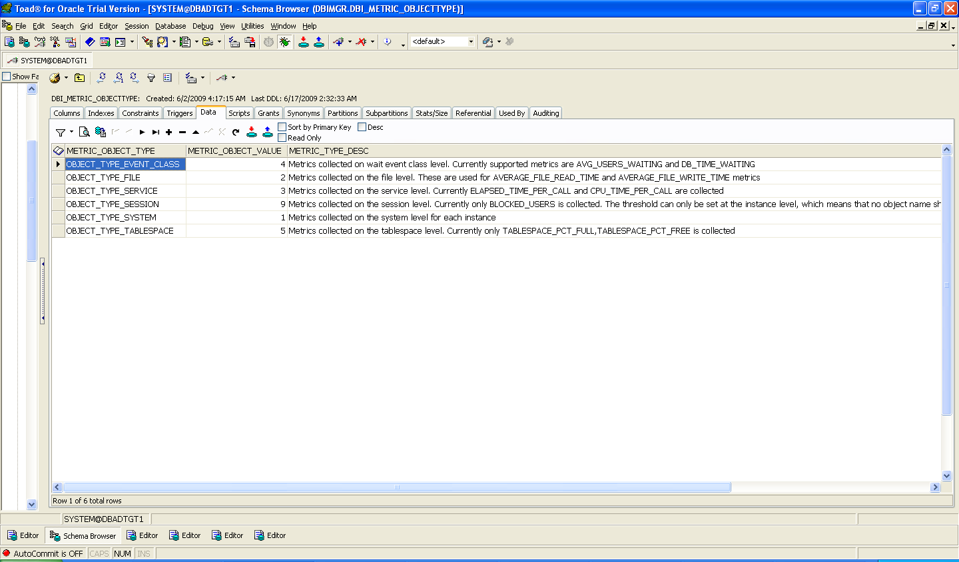

3.2 DBI_METRICS:

3.2.1 Column information:
METRIC_VAL NUMBER
METRIC_OPERATOR VARCHAR2 (100 BYTE) NOT NULL
METRIC_DESCRIPTION VARCHAR2 (1000 BYTE) NOT NULL
METRIC_UNIT VARCHAR2 (100 BYTE) NOT NULL
METRIC_OBJECT_TYPE_VAL NUMBER NOT NULL
METRIC_ID NUMBER NOT NULL

METRIC_VAL – This column contain value, which gives a unique identifier to each operator metrics. This contains a PK and cannot be duplicated.
METRIC_OPERATOR – This column contains the list of operator that is available for enabling an alert in the system. This column cannot be NULL.
METRIC_DESCRIPTION – this column gives a brief description on operator that has been described in the metric_operator column. This column cannot be NULL.
METRIC_UNIT – This gives information on the units that operator will measure. This column cannot be NULL.
METRIC_OBJECT_TYPE_VAL – This is the value of the object type that is accepted by the operator and this is obtained from the table DBI_METRIC_OBJECT_TYPE, where this column is been referenced by a FK. This column cannot be NULL.
METRIC_ID – This is inbuilt value that the DBMS_SERVER_ALERT maccepts when you call one of the operators listed in the METRIC_OPERATOR, and our procedure (add/remove) uses this value to enable/disable an operator. This column cannot and should not be NULL.

3.2.2 Adding/inserting a new data in the existing dbi_metric table.
If a version of oracle has new alerting metrics defined, you can add them to this list as per the example below.
Eg.s if as per the documents published by oracle if REDO_GENERATED_SEC is a new alert metrics and as per the document if this belongs to the object_type_system then
METRIC_VAL - any unique identifier and a value that is not already defined in the table let’s give it 20 here
METRIC_OPERATOR - REDO_GENERATED_SEC
METRIC_DESCRIPTION - Redo Generated (for each second) [As per the document]
METRIC_UNIT - Redo Bytes for each Second [As per the document]
METRIC_OBJECT_TYPE_VAL – 1 [As per the document and the as per the value defined in the table dbi_metric_object_type for that object_type]
METRIC_ID – 2016 - it is obtained from the file dbmsslrt.sql under the directory $ORACLE_HOME/rdbms/admin/

cat $ORACLE_HOME/rdbms/admin/dbmsslrt.sql |grep REDO_GENERATED_SEC
REDO_GENERATED_SEC CONSTANT BINARY_INTEGER := 2016;
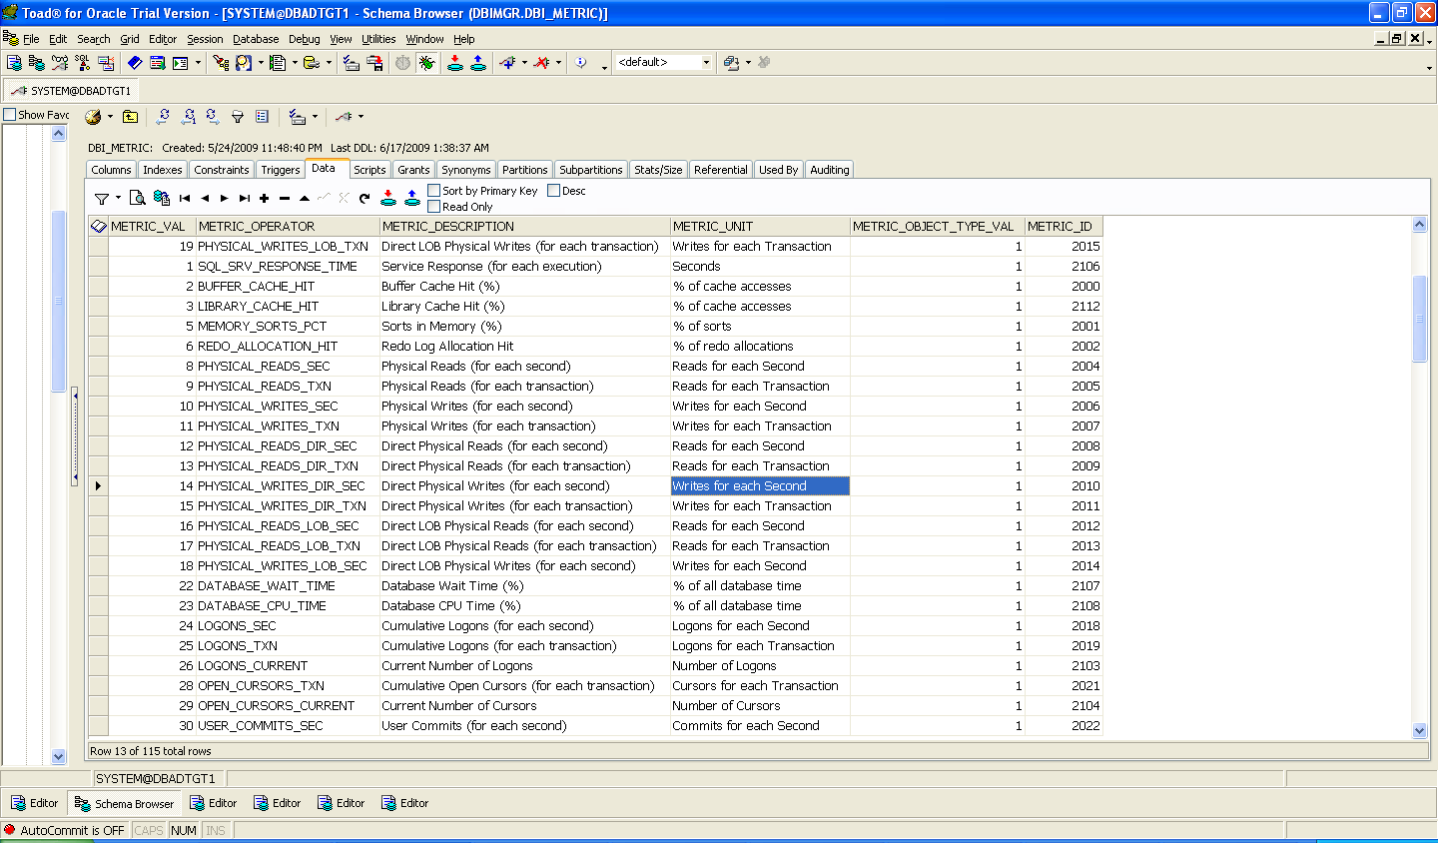
3.2.3 Dependenices:
DBI_METRIC_OBJECT_TYPE => METRIC_OBJECT_VALUE
3.2.4 Dependent objects:
DBI_METRIC_THRESHOLD=>METRIC_VAL

3.3 DBI_METRIC_OPERATOR

3.3.1 Column information:
METRIC_OPER_NAME VARCHAR2 (30 BYTE) NOT NULL
METRIC_OPER_VALUE NUMBER
METRIC_OPER_DESC VARCHAR2 (1000 BYTE) NOT NULL
METRIC_OPER_NAME - The names of the operator that is defined to be used for a version of oracle. This column is not null.
METRIC_OPER_VALUE - The value that has been defined for the given METRIC_OPER_NAME value. This is a primary key column.
METRIC_OPER_DESC – A little description of the operator and what it is used for. This column is not null.

3.3.2 Adding/inserting a new data in the existing dbi_metric_operator table.
Lets take for example OPERATOR_GT is the new object_type defined for a version of oracle , in that case as per the document on the DBMS_SERVER_ALERT for that version
METRIC_OPER_NAME - OPERATOR_GT [as per the document]
METRIC_OPER_VALUE – 0 - it is obtained from the file dbmsslrt.sql under the directory $ORACLE_HOME/rdbms/admin/
cat $ORACLE_HOME/rdbms/admin/dbmsslrt.sql |grep OPERATOR_GT
OPERATOR_GT CONSTANT BINARY_INTEGER := 0;
METRIC_OPER_DESC – A brief description on the operator [As per the document]
3.3.3 Dependenices:
NONE

3.3.4 Dependent objects:
DBI_METRIC_THRESHOLD => METRIC_WARN_OPERATOR
DBI_METRIC_THRESHOLD => METRIC_CRCTL_OPERATOR
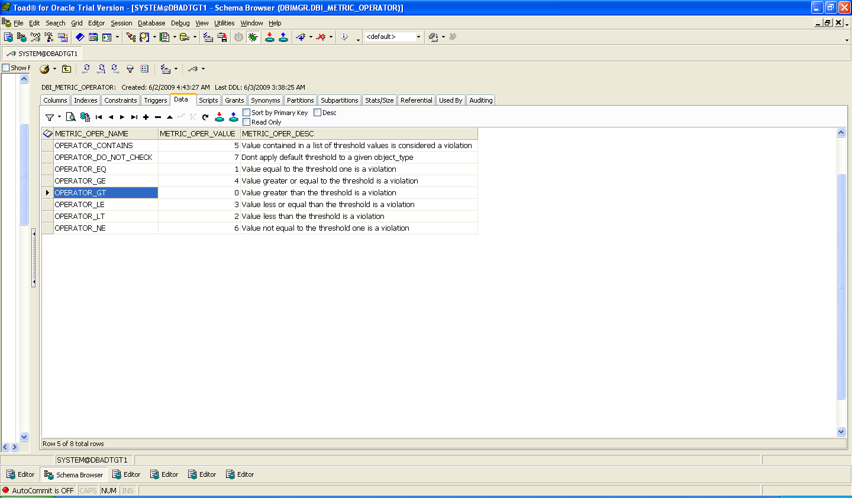

3.4 DBI_METRIC_THRESHOLD

This is a user defined table and if anyone wants an alert that need to be enabled should be entering the value here.
3.4.1 Column information:
METRIC_VAL NUMBER NOT NULL
METRIC_WARN_OPERATOR NUMBER NOT NULL
METRIC_WARN_THRESHOLD NUMBER NOT NULL
METRIC_CRTCL_OPERATOR NUMBER NOT NULL
METRIC_CRTCL_THRESHOLD NUMBER NOT NULL
METRIC_OBSRVTN_THRESHOLD NUMBER NOT NULL
METRIC_OBJECTS VARCHAR2(200 BYTE)
METRIC_FLAG VARCHAR2(1 BYTE) NOT NULL
METRIC_INSTANCE_NAME VARCHAR2(30 BYTE)

METRIC_VAL - This value is defined from the data that is available from the table DBI_METRIC=> METRIC_VAL column; it lets the package know by this value what needs to be enabled.
METRIC_WARN_OPERATOR/METRIC_CRTCL_OPERATOR – The operator information is extracted from the table DBI_METRIC_OPERATOR. Once the data is entered it lets the package know what warning or critical operator should be used for the defined METRIC_VAL.
METRIC_WARN_THRESHOLD/METRIC_CRTCL_THRESHOLD – The operator thresholds that needs to be set for a defined METRIC_VAL.
METRIC_OBSRVTN_THRESHOLD - The Observation period for the defined metric_val
METRIC_OBJECTS – If the object_type accepts any object name then need to define in this column.
METRIC_FLAG – To enable/disable a given Metrics.
METRIC_INSTANCE_NAME– the Instance name that the database is currently running on, its mandatory important when dealing with RAC instance

3.4.2 Adding/inserting a new data in the existing dbi_metric_threshold table.
If you want to enable/disable an alert - for eg. REDO_GENERATED_SEC then
METRIC_VAL - 20 [this is from the information taken from the table DBI_METRIC=>METRIC_VAL.]
METRIC_WARN_OPERATOR/METRIC_CRTCL_OPERATOR – 4/4 [this is from the information taken from the table DBI_METRIC_OPERATOR=> METRIC_OPER_VALUE]
METRIC_WARN_THRESHOLD/METRIC_CRTCL_THRESHOLD – 85 / 97 [this is the value that needs to be warned by the system when REDO_GENERATED_SEC is greater than or equal to 85 and notified about its criticality when its >= 97 ]
METRIC_OBSRVTN_THRESHOLD – 30 [check the system every 30 minutes for the defined threshold]
METRIC_OBJECTS – BLANK or NULL - since REDO_GENERATED_SEC is of the OBJECT_TYPE_SYSTEM
FOR OBJECT_TYPE [defined in the dbi_metric=>METRIC_OBJECT_TYPE_VAL] for the given metric_id if it falls in the category below, the metric_object information can be extracted from
OBJECT_TYPE_FILE - select name from v$datafile;
OBJECT_TYPE_SERVICE – select SERVICE_NAME from v$servicemetric;
OBJECT_TYPE_TABLESPACE - select name from v$tablespace;
OBJECT_TYPE_EVENT_CLASS - select distinct wait_class from dba_hist_event_name;
OBJECT_TYPE_SESSION - you can leave this section as blank for this object_type as it doesn’t accept any object value.
OBJECT_TYPE_SYSTEM – you can leave this section as blank for this object_type as it doesn’t accept any object value.
METRIC_FLAG – Y or N - To enable/disable a given Metric.
METRIC_INSTANCE_NAME - database name in case on non RAC and instance name in case of RAC

3.4.3 Dependenices:
DBI_METRIC_THRESHOLD => METRIC_WARN_OPERATOR
DBI_METRIC_THRESHOLD => METRIC_CRCTL_OPERATOR
DBI_METRIC => METRIC_VAL

3.4.4 Dependent objects:
NONE

3.5 DBI_METRIC_ALERT_GENERATION

This is the only table is not available for the user to update or modify its only for the program to update/insert on the alerts that has been generated for a given threshold, and it also make sure that one Tivoli is generated per day.
3.5.1 Column information:
OBJECT_TYPE VARCHAR2 (100 BYTE) NOT NULL
OBJECT_NAME VARCHAR2 (200 BYTE) NOT NULL
ALERT_TIME DATE DEFAULT sysdate NOT NULL
ALERT_INTERVAL NUMBER DEFAULT 24 NOT NULL
ALERT_THRESHOLD NUMBER DEFAULT 75 NOT NULL
OBJECT_TYPE – This column identifies the alert that has reached the threshold via a object_type which is generated based on the alert mechanism from the procedure DBI_ALERT_REPORT_P.
OBJECT_NAME – Based on the object_type information (dbi_metric=>metric_object_type_val) for a enabled alert the information is stored .
ALERT_TIME - The time when the alert was generated.
ALERT_INTERVAL - The alert interval time when the next alert should be generated.
ALERT_THRESHOLD - The Threshold for which the alert has been created, this information is extracted from the threshold value which has been defined from the table DBA_METRIC_THERSHOLD.

4.0 Procedure.

4.1 DBI_ALERT_ADD_P

4.1.1 Flow chart (see below)

Start
Is object_type is of the tyoe object_type_tablesopace and is the warning operator do_not_check
Is flag=Y

extract values in dbi_metric_threshold with flag set to Y via a loop
Change the value of the warning threshold.
Yes Yes Yes

No Yes
No
Is object_type is of the tyoe object_type_tablesopace and is the critical operator do_not_check
Is object_type is not of the tyoe object_type_tablesopace and is the warning operator do_not_check
Change the value of the warning threshold and warning operator
Yes No Yes
Change the value of the critical threshold.
No yes

No Yes
No
Is object_type is not of the tyoe object_type_tablesopace and is the critical operator do_not_check

Change the value of the critical threshold and critical operator
Yes

yes
No
End loop for flag=y is it zero
Call the DBMS_SERVER_ALERT to add /modify the alert for a given operator
Stop
Yes Yes

NO No

4.1.2 Dependencies

Dbi_metric_alert_generation
Dbi_metric
Sys.dbms_server_alert

4.1.3 Dependent objects
Dbi_alert_report_p

4.2 DBI_ALERT_REMOVE_P

4.2.1 Flow chart (see below)

start

Is flag=N
Is the object_type of the type object_type_tablespace

extract values in dbi_metric_threshold with flag set to N via a loop
Call the DBMS_SERVER_ALERT to remove the alert for a given operator and object_type of object_tyoe_tablespace

Call the DBMS_SERVER_ALERT to remove the alert for a given operator and object_type not of object_tyoe_tablespace

End loop for flag=y is it zero
stop
yes Yes yes yes

No Yes
No

Yes

No

Yes

4.2.2 Dependencies

Dbi_metric_alert_generation
Dbi_metric
4.2.3 Dependent objects
Dbi_alert_report_p
Sys.dbms_server_alert

4.3 DBI_ALERT_REPORT_P

4.3.1 Flow chart (see below)

Is Flag=y
Yes Yes
start
Call procedure Dbi_alert_add_p
Extract data from dbi_metric_threshol table
Is Flag=N
Call procedure Dbi_alert_remove_p
Read data from sys table dba_outstanding_alert for any alert that has been generated via a loop.
Is object_name=SYSTEM
Extract warn and crtcl threshold using dbi_thresholds
Is object_type = tablespace space usage
Convert the value of warn and critical from Kilobytes to megabytes.
Yes
Read data from dba_metric_alert_generation
Is critical threshold reachead
Has the alert generated in the day
Generate alert and update/insert in table dbi_metric_alert_generation
Is warning threshold reachead
Stop
No Yes
No
Yes No Yes

No
Yes
Yes yes
Extract warn and crtcl threshold joining wr$_outsanding table and dbi_thresholds

Yes
Yes
No yes

Yes Yes Yes

No yes
No

Yes
No
Stop
Is the loop over
yes
No

4.3.2 Dependencies.
Sys.Dba_outstanding_alert
Sys.wri$_alert_outstanding
Sys.dba_thresholds
dbi_metric_threshold
dbi_metric_alert_generation
dbi_alert_f – function
dbi_alert_add_p
dbi_alert_remove_p
4.1.3 Dependent objects
None

5.0 Errors and Troubleshooting.

5.1 DBI_METRIC

5.1.1 ORA-00001: unique constraint (DBIMGR.DBIMGR_METRIC_PK) violated.
Cause:
The value inserted in the column METRIC_VAL is not unique, the value already exist in the table.
Solution
Try passing a new value to the column METRIC_VAL
5.1.2 ORA-01400: cannot insert NULL into ("DBIMGR"."DBI_METRIC"."METRIC_VAL")
Cause:
The column METRIC_VAL is set to NULL
Solution
Try passing a value to the column METRIC_VAL

5.1.3 ORA-01400: cannot insert NULL into ("DBIMGR"."DBI_METRIC"."METRIC_OPERATOR")
Cause:
The column METRIC_OPERATOR is set to NULL
Solution
Try passing a value to the column METRIC_OPERATOR

5.1.4 ORA-01400: cannot insert NULL into ("DBIMGR"."DBI_METRIC"."METRIC_DESCRIPTION")
Cause:
The column METRIC_DESCRIPTION is set to NULL
Solution
Try passing a value to the column METRIC_DESCRIPTION

5.1.5 ORA-01400: cannot insert NULL into ("DBIMGR"."DBI_METRIC"."METRIC_UNIT")
Cause:
The column METRIC_UNIT is set to NULL
Solution
Try passing a value to the column METRIC_UNIT

5.1.6 ORA-02291: integrity constraint (DBIMGR.DBI_METRIC_R01) violated - parent key not found
Cause:
The Value described for the column METRIC_OBJECT_TYPE_VAL isn’t found in the master table DBI_METRIC_OBECTTYPE
Solution
Identify the value from the master table DBI_METRIC_OBECTTYPE and then pass the value to the column the column METRIC_OBJECT_TYPE_VAL , else add a new entry in the master table DBI_METRIC_OBECTTYPE and then pass on the value.

5.1.7 ORA-01400: cannot insert NULL into ("DBIMGR"."DBI_METRIC"."METRIC_OBJECT_TYPE_VAL")
Cause:
The column METRIC_OBJECT_TYPE_VAL is set to NULL
Solution
Try passing a value to the column METRIC_OBJECT_TYPE_VAL
5.1.8 ORA-01400: cannot insert NULL into ("DBIMGR"."DBI_METRIC"."METRIC_ID")
Cause:
The column METRIC_ID is set to NULL
Solution
Try passing a value to the column METRIC_ID

5.2 DBI_METRIC_OBJECTTYPES

5.2.1 ORA-01400: cannot insert NULL into ("DBIMGR"."DBI_METRIC_OBJECTTYPE"."METRIC_OBJECT_TYPE")
Cause:
The column METRIC_OBJECT_TYPE is set to NULL
Solution
Try passing a value to the column METRIC_OBJECT_TYPE

5.2.2 ORA-00001: unique constraint (DBIMGR.DBI_METRIC_OBJECTTYPE_PK) violated
Cause:
The value inserted in the column METRIC_OBJECT_VALUE is not unique , the value already exist in the table.
Solution
Try passing a new value to the column METRIC_OBJECT_VALUE

5.2.3 ORA-01400: cannot insert NULL into ("DBIMGR"."DBI_METRIC_OBJECTTYPE"."METRIC_OBJECT_VALUE")
Cause:
The column METRIC_OBJECT_VALUE is set to NULL
Solution
Try passing a value to the column METRIC_OBJECT_VALUE

5.2.4 ORA-01400: cannot insert NULL into ("DBIMGR"."DBI_METRIC_OBJECTTYPE"."METRIC_TYPE_DESC")
Cause:
The column METRIC_TYPE_DESC is set to NULL
Solution
Try passing a value to the column METRIC_TYPE_DESC

5.3 DBI_METRIC_OPERATOR
5.3.1 ORA-01400: cannot insert NULL into ("DBIMGR"."DBI_METRIC_OPERATOR"."METRIC_OPER_NAME")
Cause:
The column METRIC_OPER_NAME is set to NULL
Solution
Try passing a value to the column METRIC_OPER_NAME

5.3.2 ORA-00001: unique constraint (DBIMGR.DBI_METRIC_OPERATOR_PK) violated
Cause:
The value inserted in the column METRIC_OPER_VALUE is not unique , the value already exist in the table.
Solution
Try passing a new value to the column METRIC_OPER_VALUE

5.3.3 ORA-01400: cannot insert NULL into ("DBIMGR"."DBI_METRIC_OPERATOR"."METRIC_OPER_VALUE")
Cause:
The column METRIC_OPER_VALUE is set to NULL
Solution
Try passing a value to the column METRIC_OPER_VALUE

5.3.4 ORA-01400: cannot insert NULL into ("DBIMGR"."DBI_METRIC_OPERATOR"."METRIC_OPER_DESC")
Cause:
The column METRIC_OPER_DESC is set to NULL
Solution
Try passing a value to the column METRIC_OPER_DESC

5.4 DBI_METRIC_THRESHOLD
5.4.1 ORA-02291: integrity constraint (DBIMGR.DBI_METRIC_THRESHOLD_R03) violated - parent key not found
Cause:
The Value described for the column METRIC_VAL isn’t found in the master table DBI_METRIC
Solution
Identify the value from the master table DBI_METRIC and then pass the value to the column the column METRIC_VAL , else add a new entry in the master table DBI_METRIC and then pass on the value.

5.4.2 ORA-02291: integrity constraint (DBIMGR.DBI_METRIC_THRESHOLD_R02) violated - parent key not found
Cause:
The Value described for the column METRIC_CRCTL_OPERATOR isn’t found in the master table DBI_METRIC_OPERATOR
Solution
Identify the value from the master table DBI_METRIC_OPERATOR and then pass the value to the column the column METRIC_CRCTL_OPERATOR, else add a new entry in the master table DBI_METRIC_OPERATOR and then pass on the value.

5.4.3 ORA-02291: integrity constraint (DBIMGR.DBI_METRIC_THRESHOLD_R01) violated - parent key not found
Cause:
The Value described for the column METRIC_WARN_OPERATOR isn’t found in the master table DBI_METRIC_OPERATOR
Solution
Identify the value from the master table DBI_METRIC_OPERATOR and then pass the value to the column the column METRIC_WARN_OPERATOR, else add a new entry in the master table DBI_METRIC_OPERATOR and then pass on the value.

5.4.4 ORA-01400: cannot insert NULL into ("DBIMGR"."DBI_METRIC_THRESHOLD"."METRIC_VAL")
Cause:
The column METRIC_OPER_DESC is set to NULL
Solution
Try passing a value to the column METRIC_OPER_DESC

5.4.5 ORA-01400: cannot insert NULL into ("DBIMGR"."DBI_METRIC_THRESHOLD"."METRIC_WARN_OPERATOR")
Cause:
The column METRIC_OPER_DESC is set to NULL
Solution
Try passing a value to the column METRIC_OPER_DESC

5.4.6 ORA-01400: cannot insert NULL into ("DBIMGR"."DBI_METRIC_THRESHOLD"."METRIC_WARN_ THRESHOLD ")
Cause:
The column METRIC_OPER_DESC is set to NULL
Solution
Try passing a value to the column METRIC_OPER_DESC

5.4.7 ORA-01400: cannot insert NULL into ("DBIMGR"."DBI_METRIC_THRESHOLD"."METRIC_CRCTL_OPERATOR")
Cause:
The column METRIC_OPER_DESC is set to NULL
Solution
Try passing a value to the column METRIC_OPER_DESC

5.4.8 ORA-01400: cannot insert NULL into ("DBIMGR"."DBI_METRIC_THRESHOLD"."METRIC_CRCTL_ THRESHOLD ")
Cause:
The column METRIC_OPER_DESC is set to NULL
Solution
Try passing a value to the column METRIC_OPER_DESC

5.4.9 ORA-01400: cannot insert NULL into ("DBIMGR"."DBI_METRIC_THRESHOLD"." METRIC_OBSRVTN_THRESHOLD ")
Cause:
The column METRIC_OPER_DESC is set to NULL
Solution
Try passing a value to the column METRIC_OPER_DESC

5.4.10 ORA-01400: cannot insert NULL into ("DBIMGR"."DBI_METRIC_THRESHOLD"." METRIC_FLAG ")
Cause:
The column METRIC_OPER_DESC is set to NULL
Solution
Try passing a value to the column METRIC_OPER_DESC

5.4.11 ORA-02290: check constraint (DBIMGR.DBI_METRIC_THRESHOLD_C01) violated
Cause:
You are trying to add values for METRIC_FLAG which is invalid
Solution
Add value which is valid, the column METRIC_FLAG accept values in ('Y','N','y','n')

5.4.12 ORA-02290: check constraint (DBIMGR.DBI_METRIC_THRESHOLD_C02) violated
Cause:
You are trying to add values for metric_crctl_threshold which is invalid
Solution
Add value which is valid, ie
when
metric_crtcl_operator=3 then metric_crtcl_threshold should be less to metric_warn_threshold
metric_crtcl_operator=2 then metric_crtcl_threshold should be less to metric_warn_threshold
metric_crtcl_operator=4 then metric_crtcl_threshold should be greater to metric_warn_threshold
metric_crtcl_operator=0 then metric_crtcl_threshold should be greater to metric_warn_threshold
5.4.13 ORA-02290: check constraint (DBIMGR.DBI_METRIC_THRESHOLD_C03) violated
Cause:
You are trying to add values for METRIC_OBSRVTN_THRESHOLD which is invalid
Solution
Add value which is valid, the column METRIC_OBSRVTN_THRESHOLD accept values between 30 and 60
5.4.14 ORA-02290: check constraint (DBIMGR.DBI_METRIC_THRESHOLD_C04) violated
Cause:
You are trying to add values for METRIC_CRTCL_OPERATOR/METRIC_WARN_OPERATOR which is invalid
Solution
Add value which is valid, the column METRIC_CRTCL_OPERATOR/METRIC_WARN_OPERATOR does not accept values the operator 5
5.4.15 ORA-02290: check constraint (DBIMGR.DBI_METRIC_THRESHOLD_C05) violated
Cause:
You are trying to add values for METRIC_CRTCL_OPERATOR/METRIC_WARN_OPERATOR which is invalid
Solution
Add value which is valid, the column METRIC_CRTCL_OPERATOR/METRIC_WARN_OPERATOR should be equal
5.4.16 ORA-02290: check constraint (DBIMGR.DBI_METRIC_THRESHOLD_C06) violated
Cause:
You are trying to add values for METRIC_CRTCL_THRESHOLD/METRIC_WARN_THRESHOLD which is invalid
Solution
Add value which is valid, the column METRIC_CRTCL_THRESHOLD /METRIC_WARN_THRESHOLD should not be equal
5.4.17 ORA-02290: check constraint (DBIMGR.DBI_METRIC_THRESHOLD_C07) violated
Cause:
You are trying to add values for METRIC_WARN_OPERATOR which is invalid
Solution
Add value which is valid, i.e.
When
metric_val = 146 then Metric_warn_operator should be equal to 3 or
metric_val = 146 then Metric_warn_operator should be equal to 2
5.4.18 ORA-02290: check constraint (DBIMGR.DBI_METRIC_THRESHOLD_C08) violated
Cause:
You are trying to add values for METRIC_WARN_OPERATOR which is invalid
Solution
Add value which is valid, i.e.
When
metric_val = 145 then Metric_warn_operator should be equal to 0 or
metric_val = 145 then Metric_warn_operator should be equal to 4
5.4.19 ORA-00001: unique constraint (DBIMGR.DBI_METRIC_THRESHOLD_U01) violated
Cause:
You are trying to add values for METRIC_VAL , METRIC_OBJECTS and METRIC_INSTANCE_NAME which is invalid
Solution:
Combining METRIC_VAL , METRIC_OBJECTS and METRIC_INSTANCE_NAME both should be unique.

6.0 Conclusion:

- DBI_METRIC is the main table that has all the operator information, this table lets user know which all alerts can be defined for a database. Except the metric_val data rest of the data is per the document.
- DBI_METRIC_OBJECTTYPE is the table which stores information on the object types that operator use, these values are also oracle generated and as per the document for that release.
- DBI_METRIC_OPERATOR is the table which has all the operator information that can be used for generating alerts based on warning/critical thresholds, this information is also as per the document for the release.
- DBI_METRIC_THRESHOLD is the user defined table which is used for any user to enable/disable the alert in a given system based on the Metric ID operator information in the main table DBI_METRIC. The value from this table is read by the procedure to enable/disable any alerts.
- DBI_METRIC_ALERT_GENERATION is the store house of all the alerts that has been generated throughout the day and it also make sure that one alerts is generated per day.
- DBI_ALERT_ADD_P is a procedure that has been used for enabling/modifying the alert based on the data and the flag that has been entered on the table DBI_METRIC_THRESHOLD.
- DBI_ALERT_REMOVE_P is a procedure that has been used for disabling the alert based on the flag that has been entered on the table DBI_METRIC_THRESHOLD.
- DBI_ALERT_REPORT_P is the main procedure, which calls the above two procedure as well as reports/alerts on any alerts that has crossed the defined threshold.

